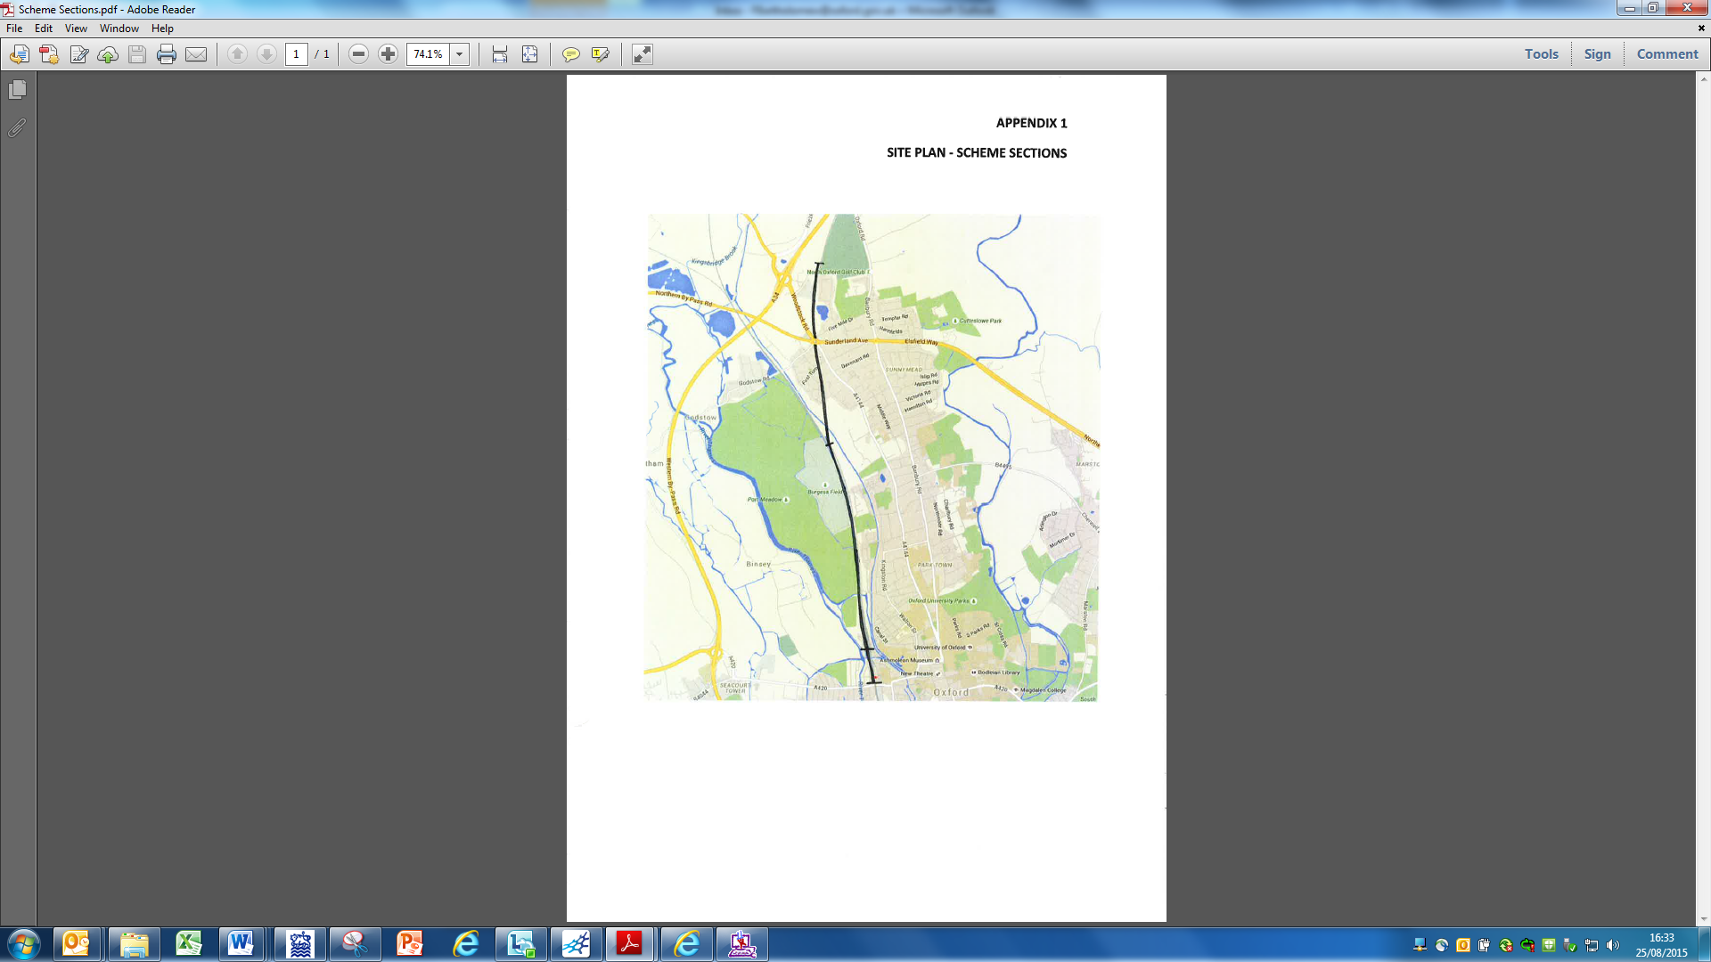

Appendix 2

**North**

**Section I**

**Section J**

**Section H**